Kubernetes Cluster Architecture
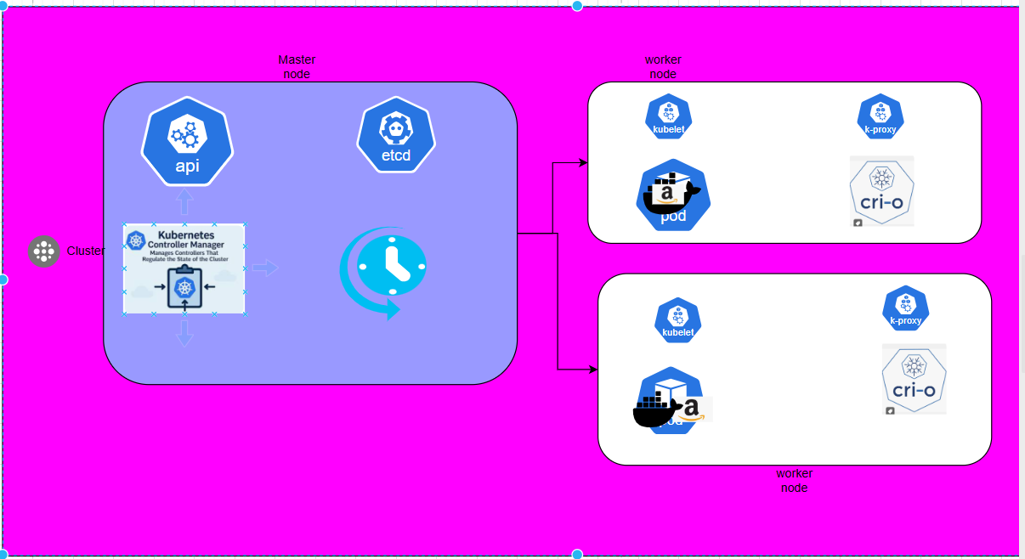
Cluster:
A cluster is a collection of vm’s (nodes) connected together to work as a single system. The main purpose of the cluster is to run applications reliably and efficiently. If one system fails, the application can still run on another system in the cluster. This improves availability and performance.

- combination of nodes
- Node is nothing but vm
- Every cluster has two type nodes

1. Master node / control plane
2. Worker node

- Master node:

> It is going to managing entire ur cluster and its actual state
Master node is heart of the cluster
Master node is responsible to make available workers node ( without master node u cant get any worker node)
Usually every cluster has one master and has multiple worker nodes
Master node has 4 components

- API Server
- ETCD
- Controller Manager
- Scheduler

1. API server:
• it is an entry point of cluster.
Whenever you run the command first request will go to the api server only
• It will validate requests and updates cluster state.
All communication between components goes through api server
It acts as the central communication point.

2.ETCD:

- ETCD is the storage component of the Kubernetes cluster. It stores all the important data related to the cluster, such as node information, pod information, and configuration details. It works like a database that keeps the cluster state safe.

Controller Manager:

The Controller Manager is responsible for maintaining the desired state of the cluster. It constantly checks whether everything is working correctly. If something fails, like a pod stops running, it takes action to fix the issue by creating a new pod or restoring the system.

Scheduler:

The Scheduler is responsible for assigning pods to worker nodes. When a new pod is created, the scheduler decides which worker node should run that pod based on resource availability and system condition.

Worker Node:

The worker node is the system where the actual application runs. It performs the work assigned by the master node. The worker node runs containers inside pods and executes the application.

Each worker node contains the following components:
- Kubelet
- Kube Proxy
- Container Runtime
- Pods

Worker Node Components

Kubelet:

Kubelet is an agent that runs on the worker node. It communicates with the master node and follows its instructions. It ensures that the containers inside the pods are running properly.

Kube-Proxy:

Kube Proxy is responsible for handling network communication. It ensures that traffic reaches the correct pod and manages network rules on the worker node.

Container Runtime:

- The container runtime is the software responsible for running containers. It pulls container images and runs them. Examples include Docker and CRI-O.

Pod:

- A pod is the smallest it is a Smallest deployable unit it is but where we are going to managing our container is called pod

